Week 1 — Full Findings Record
Heavy Supplier, Inventory & Warehouse Analytics
CadetX Virtual Work Experience — Personal record covering all 4 items completed
Contents: 1) Dataset Structure & Overview — 2) Primary & Foreign Key Mapping — 3) Table Relationship Mapping (ERD) — 4) Inventory Anomaly Investigation (current_stock vs max_stock)

1. Dataset Structure & Overview
The dataset contains 12 tables, covering the full operational flow from suppliers through warehouse stock to customer sales and payments.
Table | Rows | What it contains
branches | 6 | Warehouse/branch details (location, capacity, staff, revenue)
customers | 500 | Customer master data
products | 30 | Product master data (category, cost, price, reorder settings)
suppliers | 8 | Supplier master data (type, lead time, reliability score)
inventory_master | 180 | Stock levels per product per branch
stock_ledger | 237,230 | Full history of every stock movement (in/out/adjustment)
purchase_orders_header | 24,000 | Purchase order summaries
purchase_orders_lines | 155,495 | Line-item detail for each purchase order
sales_orders_header | 20,000 | Sales order summaries
sales_orders_lines | 130,402 | Line-item detail for each sales order
invoices | 18,033 | Billing records tied to sales orders
payments | 19,257 | Payments received against invoices

This is a realistic, transactional dataset spanning roughly 6 years (2019–2025) of activity across 6 branches.

2. Primary & Foreign Key Mapping
Table | Primary Key | Foreign Key(s)
branches | branch_id | —
customers | customer_id | —
products | product_id | —
suppliers | supplier_id | —
inventory_master | product_id + branch_id (composite) | product_id → products; branch_id → branches
purchase_orders_header | po_id | supplier_id → suppliers; branch_id → branches
purchase_orders_lines | po_id + line_number (composite) | po_id → purchase_orders_header; product_id → products
sales_orders_header | so_id | customer_id → customers; branch_id → branches
sales_orders_lines | so_id + line_number (composite) | so_id → sales_orders_header; product_id → products
invoices | invoice_id | so_id → sales_orders_header; customer_id → customers; branch_id → branches
payments | payment_id | invoice_id → invoices
stock_ledger | movement_id | product_id → products; branch_id → branches; reference_type + reference_id → either purchase_orders_header (PO) or sales_orders_header (SO)

Referential integrity verified: All key relationships were tested directly against the data — checked product_id, branch_id, supplier_id, and customer_id references across multiple tables. Zero orphan/broken references found anywhere. inventory_master also has exactly the expected 180 rows (30 products × 6 branches), confirming complete, correct coverage with no duplication.

3. Table Relationship Mapping (Entity Relationship Diagram)
Building on the key mapping above, this ERD shows how all 12 tables connect to one another.
Live, interactive version (zoomable, click stock_ledger to see the reference note): https://dbdiagram.io/d/6aa7107436f9982564809e24
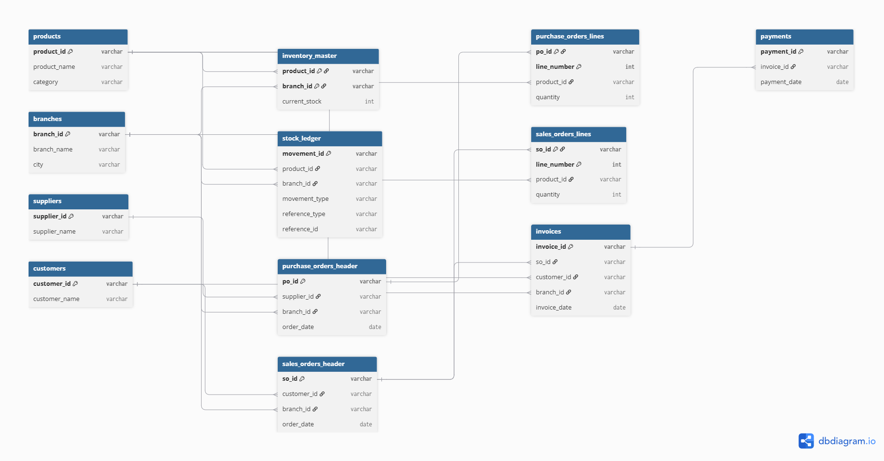

How to read this diagram
- Each box represents one table, listing its columns.
- A key icon next to a column marks it as part of that table's primary key.
- Lines connect a foreign key in one table to the primary key it references in another.

Standalone master tables
products, branches, suppliers, and customers each describe a single type of entity on their own, with no foreign keys referencing other tables.

Composite-key tables
inventory_master, purchase_orders_lines, and sales_orders_lines each exist specifically to connect two other things together, requiring two columns combined to uniquely identify each row:
- inventory_master: product_id + branch_id (this product, at this branch)
- purchase_orders_lines: po_id + line_number (this line item, within this purchase order)
- sales_orders_lines: so_id + line_number (this line item, within this sales order)

A note on stock_ledger's flexible reference
stock_ledger.reference_id is not drawn as a single fixed link, because it can point to either purchase_orders_header (when reference_type = 'PO') or sales_orders_header (when reference_type = 'SO'), depending on the row. Documented here instead of drawn: reference_id links to either purchase_orders_header.po_id or sales_orders_header.so_id, depending on the value of reference_type.

4. Inventory Anomaly Investigation — current_stock vs max_stock

Finding
All 180 rows in inventory_master show current_stock far exceeding max_stock — ranging from 177x to 854x over capacity, averaging 385x.

Investigation and root cause
- Confirmed current_stock is not an independent figure — it exactly matches the last running_balance value in stock_ledger for that product/branch (verified across all 180 rows, 100% match)
- Traced the imbalance to movement sizes: IN movements average ~160 units each (tied to purchase orders), while OUT movements average only ~10 units each (tied to sales orders) — roughly a 16x difference
- Movement counts are fairly close (127,611 IN vs 107,165 OUT), so the issue isn't frequency — it's that each delivery brings in far more than each sale removes
- Compounded over ~6 years of continuous history with no resets, the cumulative balance has grown to far exceed any realistic warehouse capacity

Why it matters
Any KPI relying on current_stock as a live snapshot (stockout risk, overstock detection, reorder-point triggers) will be meaningless if used as-is.

